Jill,

It is 56 pages long, and I would have to know what section to shorten, but Sara and I agreed to make the current diagram (see immediately below) more accessible and to have some accompanying text.

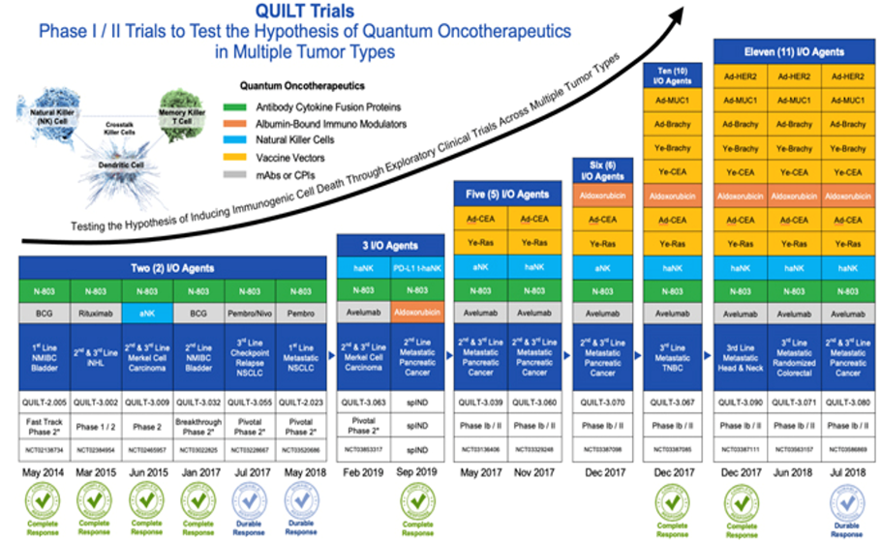

I came up with the version below (scroll down).

The accompanying text could be:

“ImmunityBio has conducted many clinical trials testing the ‘Quantum Oncotherapeutics Hypothesis’. The hypothesis is based on a ‘Triangle Offense’ designed to re-ignite both the innate and adaptive immune systems, activating natural killer (NK) and cytotoxic T cells to establish immune memory and protection against cancer relapse. The Triangle Offense utilizes temporal (specifically-timed) orchestrated combination therapy that may include our interleukin-15 (IL-15) superagonist ANKTIVA, PD-L1 targeted high-affinity NK (PD-L1 t-haNK) cells, tumor-associated antigen (TAA) or neoantigen-targeted vaccines, low-dose chemotherapy such as Abraxane®, and other immunotherapies tailored to the cancer type, stage, and line of therapy. These Quantum Integrated Lifelong Therapy (QUILT) trials have produced promising results, including durable complete responses (CRs) in Merkel Cell Carcinoma (MCC), Non-Hodgkin Lymphoma (NHL), Head & Neck Squamous Cell Carcinoma (HNSCC), Triple-Negative Breast Cancer (TNBC), and, importantly, BCG-unresponsive bladder carcinoma in situ (CIS). The latter lead to FDA approval of ANKTIVA plus BCG for BCG-unresponsive bladder CIS with or without Ta/T1 papillary disease in 2024. Many more QUILT trials are ongoing or planned.”

