ANKTIVA HCP Page for ImmunityBio [LINK PAGE TO ANKTIVA SITE)
Prescribing Info (SEE LINK TO IT HERE)
Important Safety Info in Sticky
Indication and Important Safety Information
INDICATION AND USAGE
ANKTIVA is an interleukin-15 (IL-15) receptor agonist indicated with Bacillus Calmette-Guerin (BCG) for the treatment of adult patients with BCG-unresponsive non-muscle invasive bladder cancer (NMIBC) with carcinoma in situ (CIS) with or without papillary tumors.
WARNINGS AND PRECAUTIONS
Risk of Metastatic Bladder Cancer with Delayed Cystectomy. Delaying cystectomy can lead to the development of muscle invasive or metastatic bladder cancer, which can be lethal. If patients with CIS do not have a complete response to treatment after a second induction course of ANKTIVA with BCG, reconsider cystectomy.
DOSAGE AND ADMINISTRATION
For lntravesical Use Only. Do not administer by subcutaneous or intravenous routes. Instill intravesically only after dilution. Total time from vial puncture to the completion of the intravesical instillation should not exceed 2 hours.
USE IN SPECIFIC POPULATIONS
Pregnancy: May cause fetal harm. Advise females of reproductive potential of the potential risk to a fetus and to use effective contraception.
ADVERSE REACTIONS
The most common (≥15%) adverse reactions, including laboratory test abnormalities, are increased creatinine, dysuria, hematuria, urinary frequency, micturition urgency, urinary tract infection, increased potassium, musculoskeletal pain, chills and pyrexia.
For more information about ANKTIVA, please see the Full Prescribing Information at www.anktiva.com.
You are encouraged to report negative side effects of prescription drugs to FDA. Visit www.FDA.gov/medwatch or call 1-800-332-1088. You may also contact lmmunityBio at 1-877-ANKTIVA (1-877-265-8482)
1. ANKTIVA Package insert. lmmunityBio, Inc., ; 2024. 2. Chamie K, et al. IL-15 Superagonist NAI in BCG-Unresponsive Non-Muscle-Invasive Bladder Cancer. NEJM Evid. 2023 Jan;2(1): EVIDoa2200167. doi: 10.1056/EVIDoa2200167. 3. Suderman J, et al. Re: IL-15 Superagonist NAI in BCG Unresponsive Non-muscle-invasive Bladder Cancer. Eur Ural. 2023 Jun;83(6):581. doi: 10.1016/j.eururo. 2023.01.009. 4. BCG Package insert. Merck & Co., Inc. ; 2022. 5. Chamie K, et al. Quality of Life in the Phase 2/3 Trial of N-803 Plus Bacillus Calmette-Guerin in Bacillus Calmette-Guerin Unresponsive Nonmuscle-lnvasive Bladder Cancer. Ural Pract. 2024 Mar;11(2):367-375. doi: 10.1097/UPJ.0000000000000517. 6. Han KP, et al.. IL-15:IL-15 receptor alpha superagonist complex: high-level co-expression in recombinant mammalian cells, purification and characterization. Cytokine. 2011 Dec;56(3):804-10. doi: 10.1016/j.cyto.2011.09.028. 7. One death reported due to a cardiac arrest that was unrelated to N-803 + BCG. 8. Kamat AM, Sylvester RJ, Bbhle A, Palau J, Lamm DL, Brausi M, Soloway M, Persad R, Buckley R, Colombel M, Witjes JA. Definitions, End Points, and Clinical Trial Designs for Non-Muscle-Invasive Bladder Cancer: Recommendations From the International Bladder Cancer Group. J Clin Oneel. 2016 Jun 1;34(16):1935-44. doi: 10.1200/ JCO.2015.64.4070.
MOA (GLEAN FROM CURRENT HOME PAGE HERE)
ANKTIVA is a potent immunostimulant that unlocks anti-tumor activity and promotes a durable, complete response.
ANKTIVA works by activating the body’s natural immune system to fight disease and provide long-term immune memory against the cancer.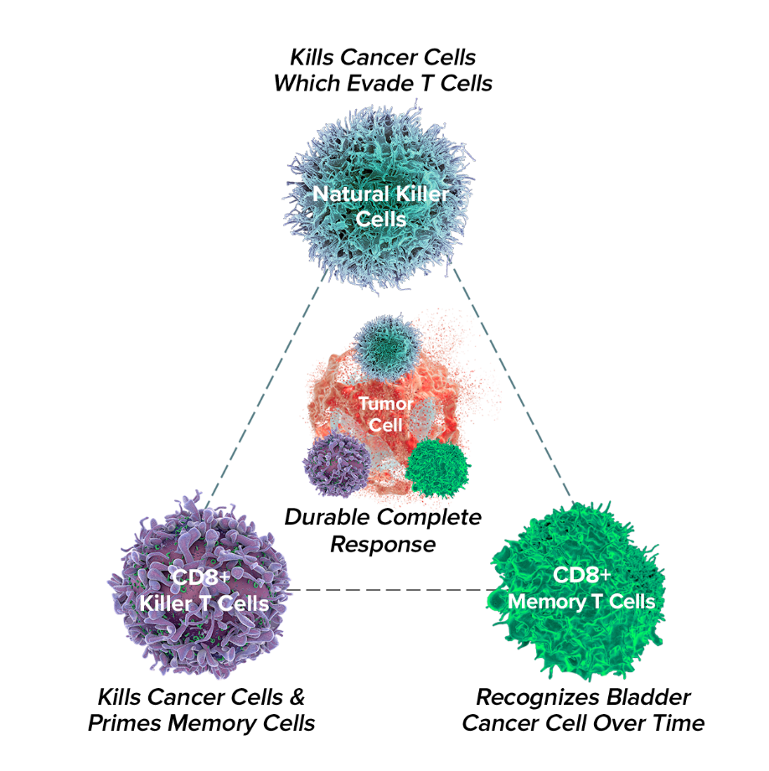
Frequently Asked Questions
What is ANKTIVA?
ANKTIVA, also known as nivolumab, is a prescription medication approved by the FDA for non-muscle invasive bladder cancer (carcinoma in situ).

How does ANKTIVA work?
ANKTIVA is an immune checkpoint inhibitor that targets and blocks a protein called PD-1 (programmed cell death protein 1). PD-1 Is found on the surface of immune cells and helps to regulate the immune response by inhibiting immune activity. By inhibiting this protein, ANKTIVA helps to enhance the body's immune response against these cancer cells.
How is ANKTIVA administered?
The designated healthcare provider will give the patient ANKTIVA through an intravenous (IV) line, with a total time of no more than 2 hours from vial puncture to the completion of the intravesical instillation.
Is there a support program for ANKTIVA?
Patients prescribed ANKTIVA for the approved indication can access additional resources through ImmunityBio CARE™ : https://www.immunitybiocaredocsign.com/ImmunityBioEsignOnDemand/s/esign-ondemand

